Project Proposal
Candidate Number: 181509
Supervisor: Peter Cheng
Working Title: Cognitive Biometric Graphical Authentication of Users
Aims and Objectives:
This project aims to create an alternative authentication system for users instead of passwords. This idea is especially safe when the user behaviour is considered. Passwords are difficult to remember, very easy to make a typo as the length increases, there are various common techniques to crack passwords and users tend to write down their passwords which creates a huge security risk. On the other hand, a graphical authentication is faster to enter, easier to remember as the human memory works better with images and the muscle memory will restore the registered pattern over time. Moreover, adding an extra analysis to pattern input time will increase the security level of the authenticator.
Primary objective is to create the graphical authenticator which consists of:
- Grid selection
- User interface
- Pattern registration
- Pattern input
- Pattern comparison
- Recording the authentication time
Secondary objective is to create an automated analysis to include the time data as a part of the authentication. This part will use the extracted data from the authenticator if the pattern is the same with the registered pattern, presumably comparing against an average constant that should be updated over a period, first gathered from registration, possibly requesting user to enter the pattern couple of times during registration of the pattern. The result of the analysis will pass as successful or failed.
Extra objective is to locate this system on a website. The benefit of achieving this objective is that the system can be tested by a greater number of users, which will allow me to evaluate the accuracy of my authentication algorithm that includes time data.
Relevance:
The plan is to implement the authenticator with Java and calculate the data gathered with Python. If I am able to implement the program on a website, I will be using HTML5, CSS and JavaScript as well. I have learnt these three languages during my education and this project will give me a chance to combine all of them. Additionally, there will be user input gathering based on graphical platform, algorithm to evaluate data gathered and web page setting and designing which is a combination of at least three modules from the past years.

Resources Required:
There will be no extra resources required that needs to be purchased to implement this project. Most of the resources will be online documents and free tools, or books and tools that are provided by the university library and labs.
Timetable:
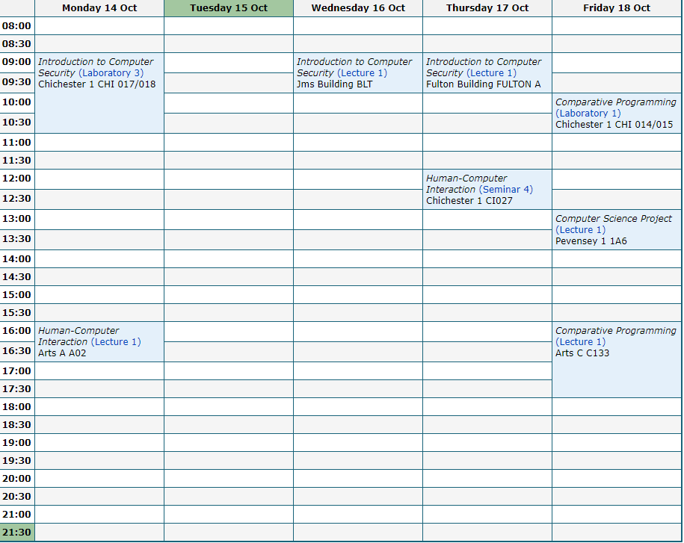
*Except the university hours I progress through the project process as much as I can, so there is not a specific time on weekly table.
Bibliography:
- Ahsan, M. and Li, Y. (n.d.). Graphical Password Authentication using Images Sequence. [online] International Research Journal of Engineering and Technology (IRJET) e-ISSN, pp.1824–1832. Available at: https://www.irjet.net/archives/V4/i11/IRJET-V4I11330.pdf [Accessed 16 Oct. 2019].
- Akram, T., Ahmad, V., Haq, I. and Nazir, M. (2017). Graphical Password Authentication. International Journal of Computer Science and Mobile Computing, 6(6), pp.394–400.
- Almulhem, A. (2011). A graphical password authentication system. World Congress on Internet Security, WorldCIS2011, pp.223–225.
- Birget, J.-C., Hong, D. and Memon, N. (2006). IEEE Transactions on Information Forensics and Security. [online] 1(3), pp.395–399. Available at: https://ieeexplore.ieee.org/abstract/document/1673401/citations#citations.
- Gokhale, M.A.S. and Waghmare, V.S. (2016). The Shoulder Surfing Resistant Graphical Password Authentication Technique. Procedia Computer Science, 79, pp.490–498.
- Martinez-Diaz, M., Fierrez, J. and Galbally, J. (2015). Graphical Password-Based User Authentication With Free-Form Doodles. IEEE TRANSACTIONS ON HUMAN-MACHINE SYSTEMS, [online] 46, pp.1–8. Available at: https://www.researchgate.net/publication/287965239_Graphical_Password-Based_User_Authentication_With_Free-Form_Doodles.
- Suo, X., Zhu, Y. and Owen, G.S. (n.d.). Graphical Passwords: A Survey. 21st Annual Computer Security Applications Conference (ACSAC’05). [online] Available at: https://www.acsac.org/2005/papers/89.pdf [Accessed 16 Oct. 2019a].
- Suo, X., Zhu, Y. and Owen, G.S. (n.d.). Graphical Passwords: A Survey. 21st Annual Computer Security Applications Conference (ACSAC’05). [online] Available at: https://www.acsac.org/2005/papers/89.pdf [Accessed 16 Oct. 2019b].
- Wiedenbeck, S., Waters, J., Birget, J.-C., Brodskiy, A. and Memon, N. (2005). Authentication Using Graphical Passwords: Effects of Tolerance and Image Choice. [online] 93, pp.1–12. Available at: https://www.researchgate.net/publication/221166384_Authentication_using_graphical_passwords_Effects_of_tolerance_and_image_choice [Accessed 16 Oct. 2019].
- Yan, J., Blackwell, A., Anderson, R. and Grant, A. (2004). Password memorability and security: empirical results. IEEE Security & Privacy Magazine, 2(5), pp.25–31.
‌Interim Log:
03/10/2019 – Discussed the aim and objective of the project and gained an idea about the initial background search ideas.
10/10/2019 – Presented background research and gained insight on how to use the materials I have gathered to create my theories about the project.

